1. Demonstrate that you have created StudentCatalog table

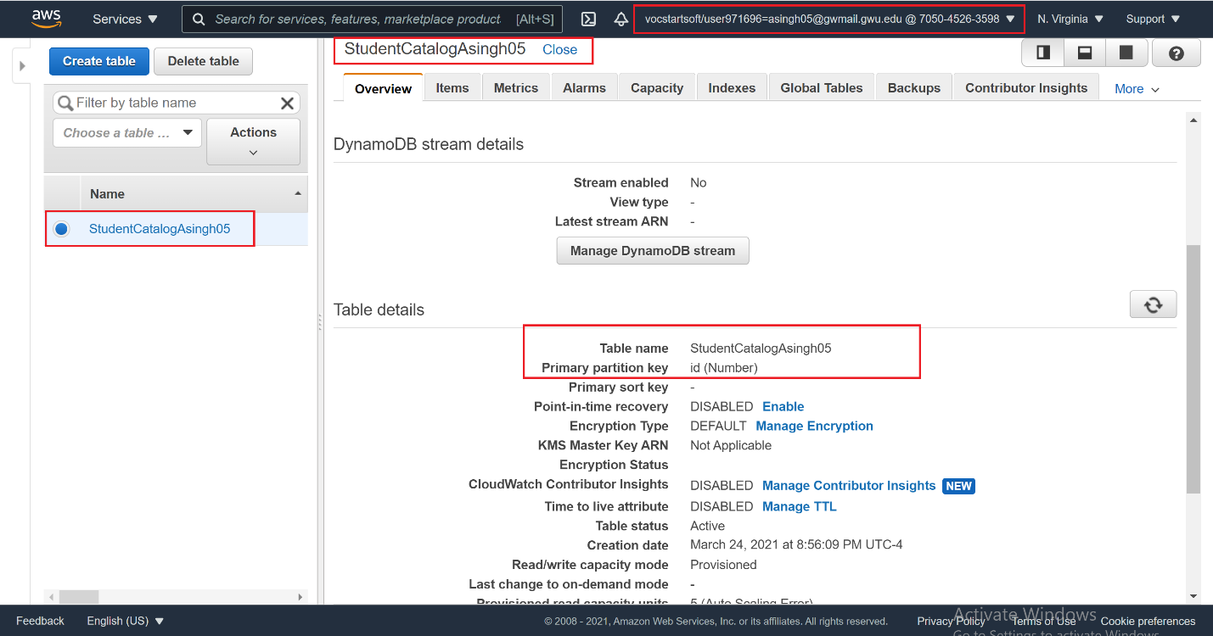

2. Demonstrate that you have added several items to your table

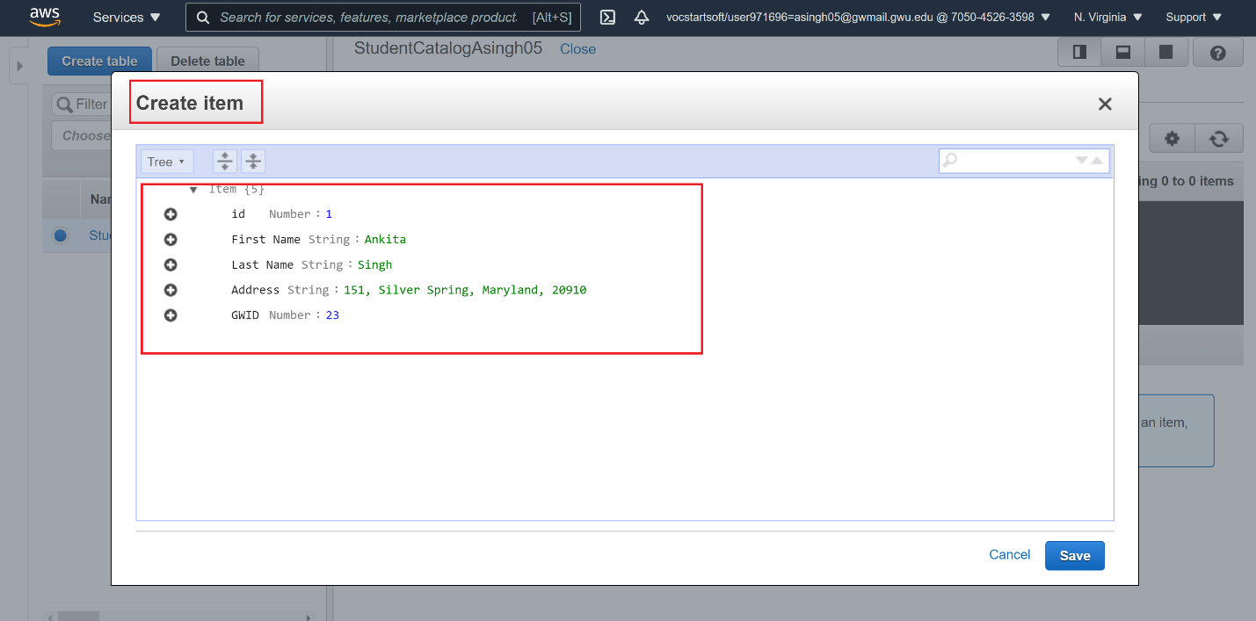

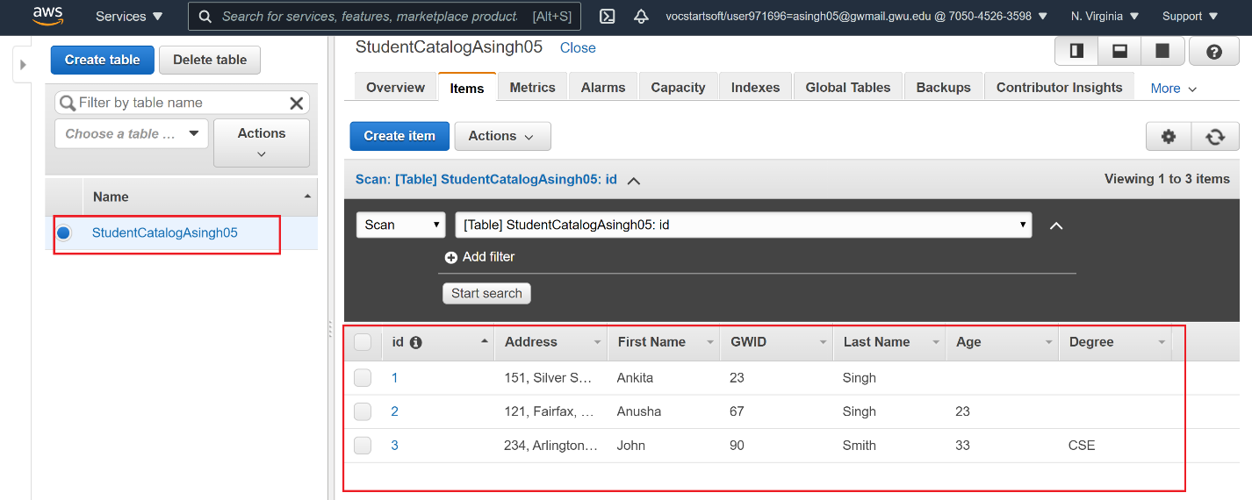

3. Demonstrate that you have updated StudentCatalog table to change Degree to Biology

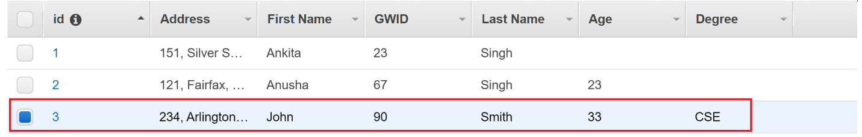

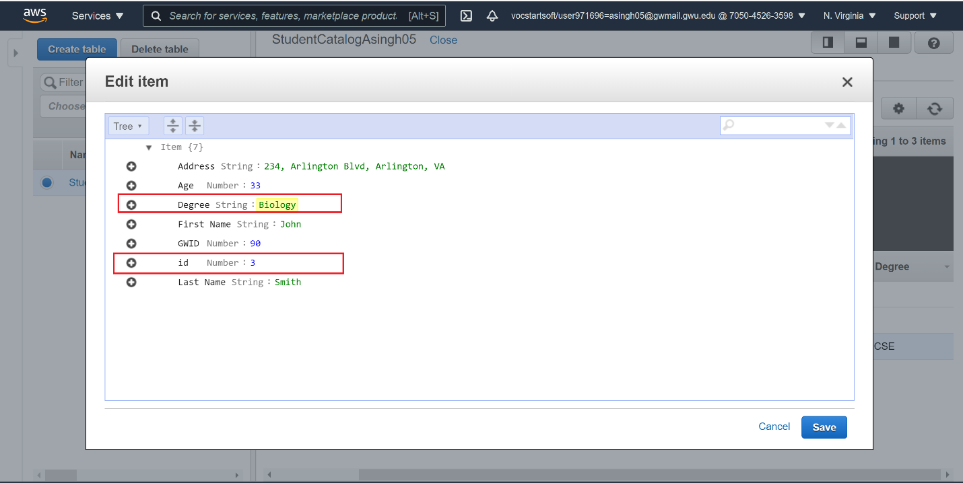

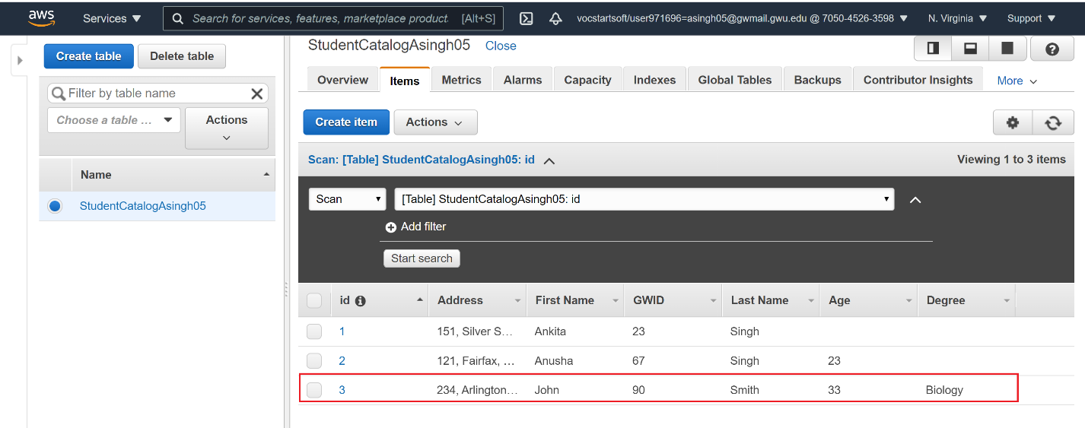

4. Demonstarte that the primary key has to be unique (you will get an error if it is not unique). Screenshot that error

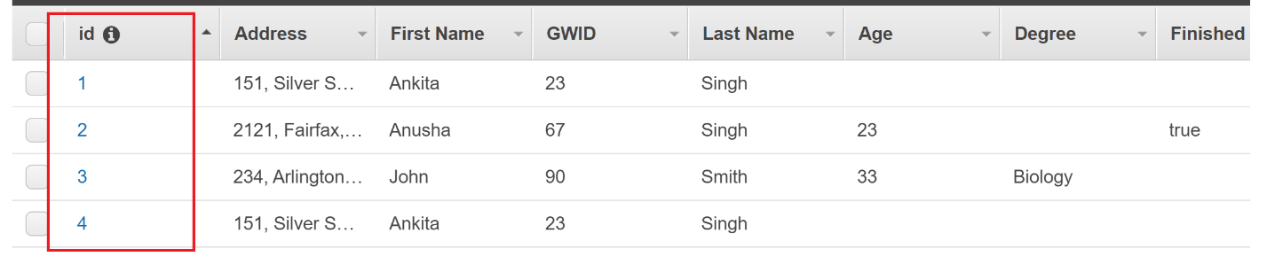

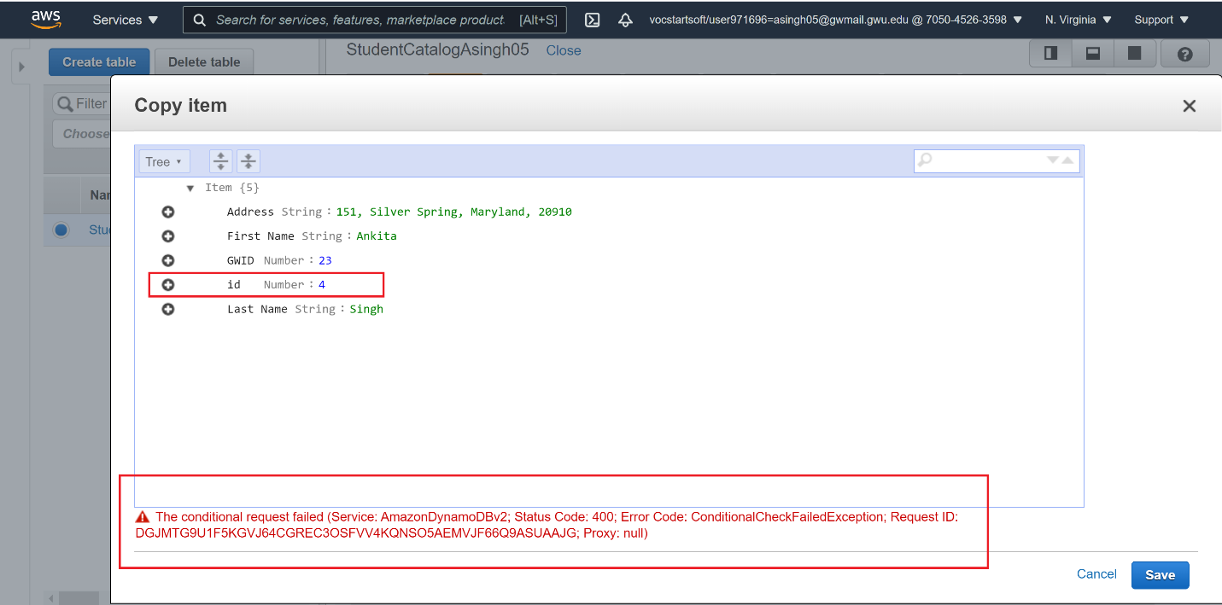

5. Demonstrate that you have added Map data type to your item

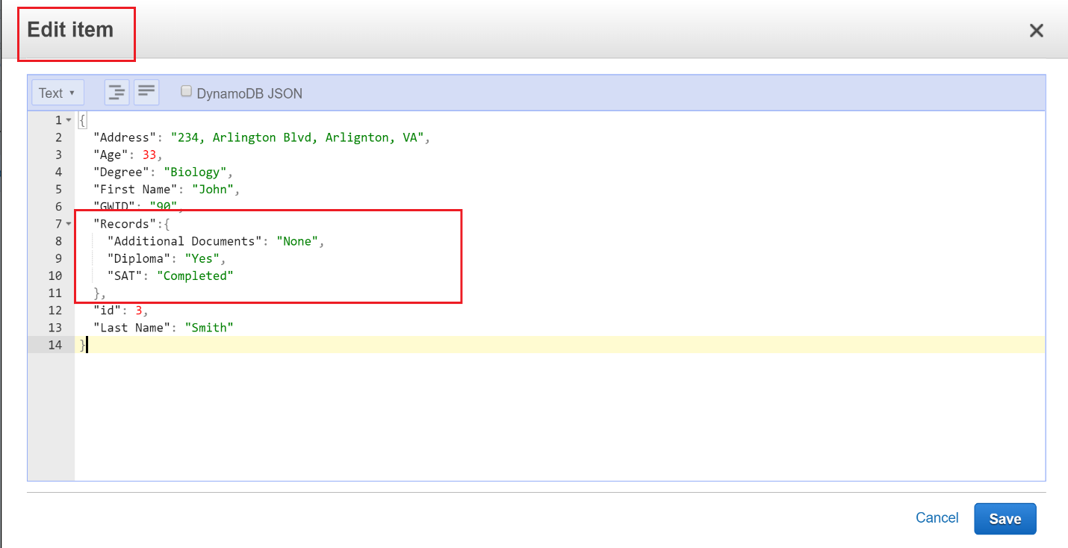

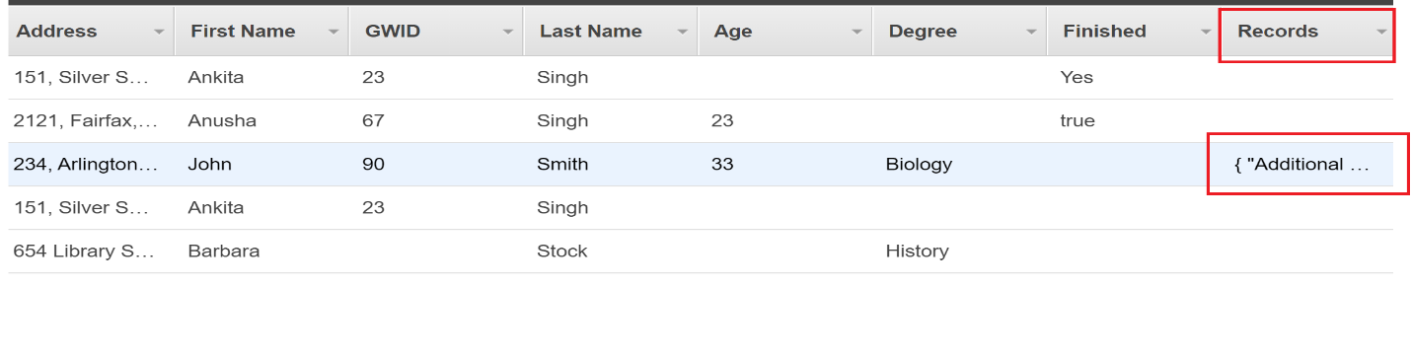

6. Demonstrate that you have added List data type to your item

